**Exercise 7: Financial Forecasting**

**Recursive Algorithms**

* **Recursion** is a method where a function calls itself to solve smaller sub-problems of the same type.
* Simplifies problems that have repeated patterns or can be broken down into smaller instances.
* Needs a **base case** to stop recursion, or it will run infinitely.

**Output**

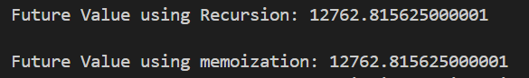

**Time Complexity**

* **Recursive Version: O(n)** (each year calls one more recursive step).
* **Memoized Version: O(n)**, but avoids redundant calculations.

**Optimization Tips**

* Recursion can be **inefficient** if it recalculates the same results multiple times.
* **Memoization** stores previous results to avoid repeated computation.